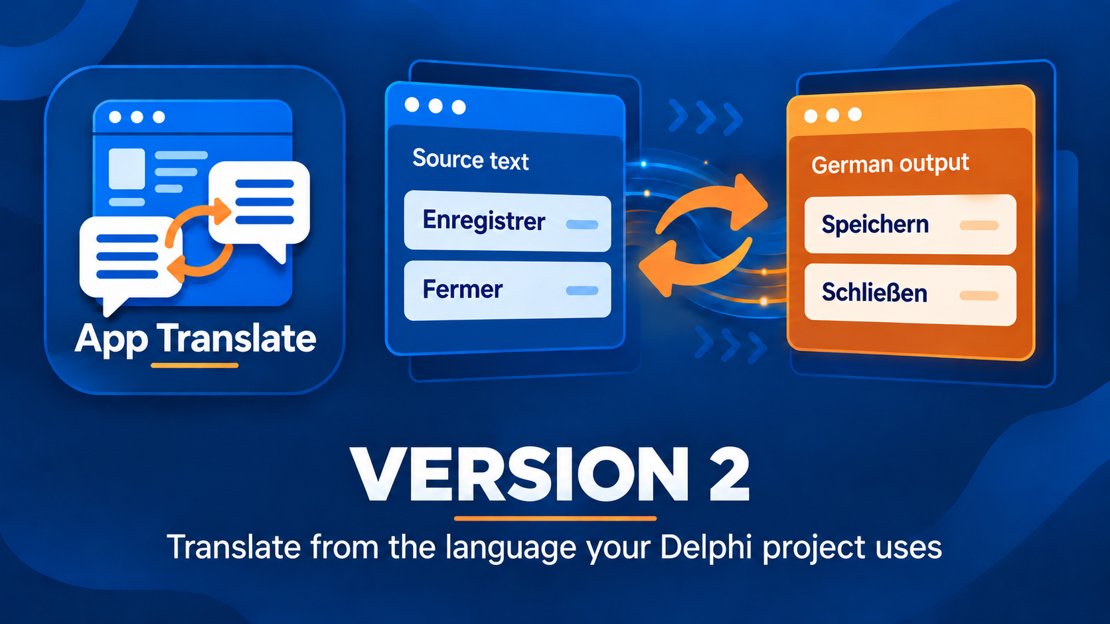

Delphi App Translation Studio Complete Test Guide
Check the workflow and the translated application
Version 2 | Last changed 7 October 2026

Contents

A sensible test order 3
Prepare a safe test copy 3
Test the Setup Wizard 3
Test translation review 4
Test validation and export 5
Test repeated language additions 6
Test the application in use 7
Test recovery and handoff 7

A sensible test order
Test a small path first: one saved Delphi project, one target language, one executable. Then add languages, more build outputs, and any separate installed or portable folders. This guide is for a developer or tester checking the finished translation workflow. It is not an instruction to alter source code just to run tests.
The source language is the language already in the project. A target language is an added display language. An editable development catalog is not a deployed runtime pack. The test passes only when the chosen executable reads the expected packs and its visible text behaves correctly.

Prepare a safe test copy
1. Use a saved project copy you are willing to scan and build. Save all forms and project files in RAD Studio.
2. Close the running target application before a build or deployment. Record the executable folder you intend to run.
3. Confirm the source language and choose one target. Have a provider key ready if automatic translation will be tested; requests may incur charges.
4. Decide whether any separate application destination is in scope. Do not add a folder merely because it exists.

Test the Setup Wizard
Open Run Setup Wizard. Verify the project choice, framework, workflow mode, build-output folders, source and target language, and translation service. Test the provider connection. On Scan Project, confirm the sample strings belong to the selected project and the counts are plausible. Unique entries can be fewer than raw occurrences because equivalent duplicates are collapsed.
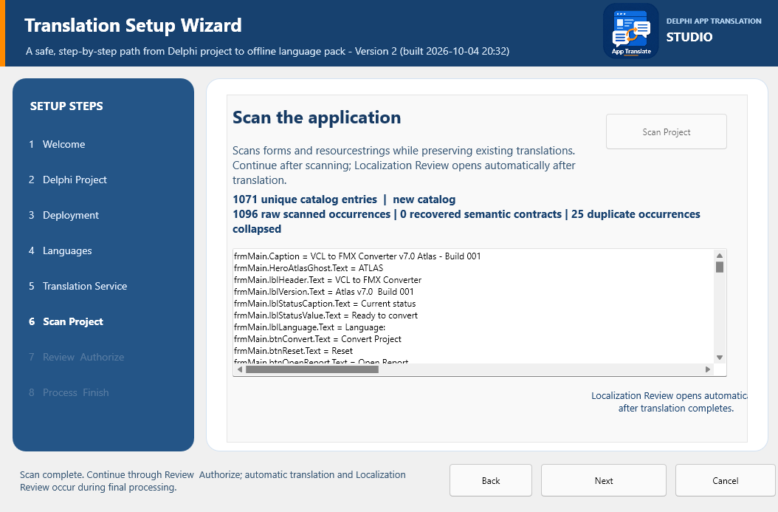
Check the project text and the scan summary before authorizing processing; the numbers in your own project will differ.
At Review and Authorize, check the destinations and safety conditions. Begin Final Processing. Confirm that the timestamped ZIP Safety Backup completes before translation starts. The progress page can take several minutes for a large project and should not allow manual deployment before successful completion. When Localization Review opens, inspect text and layout proposals; close it to let processing continue. Record any warning or error shown in the progress log rather than overlooking it.
After completion, check the project Localization\Languages folder and the Localization\Languages folder beside each intended executable. Verify the source pack and the target pack. Check that the finish options take you to Add more languages, Open Maintenance, Return to start, or manual Deploy to App Folder as labeled.

Test translation review
Open the saved catalog in Maintenance Studio. Select a source entry and compare its target text. Change a harmless test phrase, choose Apply Translation, and Save. Reopen the project and confirm the edit persists. Mark Reviewed only after a person checks the wording. Approve, when available, is a separate state. Check long labels, punctuation, keyboard shortcuts, numbers, and placeholders such as %s. A placeholder represents a value inserted by the application; it must remain compatible with the source text.
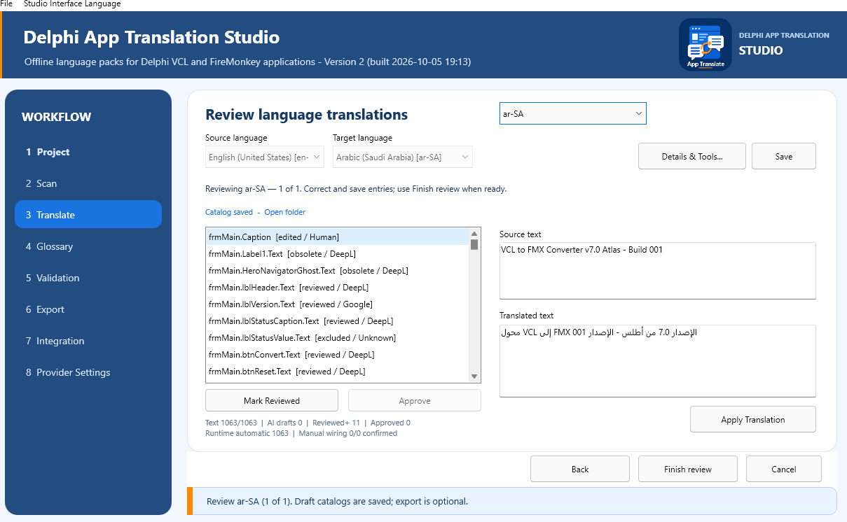
The Translate screen shows source and target text for one entry. The saved catalog can be reopened before export.

Test validation and export
Open Validation. Run Validate All Languages and read the language list. If an error appears, select that language and a specific issue, open it, correct and save the entry, then validate again. Warnings request attention but need not block export. Confirm that a language with errors remains a saved draft while ready languages can be exported.
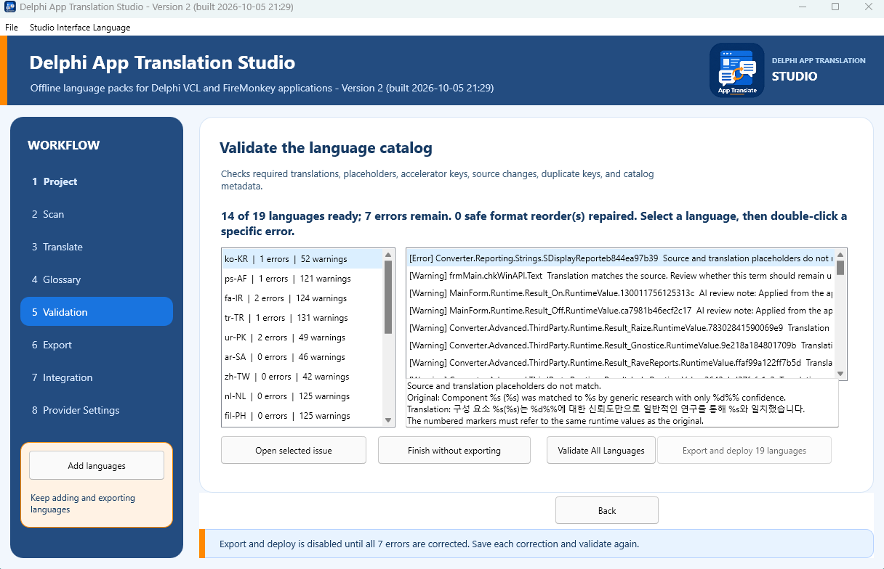
An error state should point to an affected language and entry; it is not a reason to retranslate every language.
On Export, review all ready languages and every displayed destination. Confirm which language packs will replace deployed files. Choose Export and deploy. Check the files and timestamps in the project and executable folders, then run that exact executable. The exported pack set should include the source language and each ready target. An archived portable export should not change unless you explicitly create or update one.

Test repeated language additions
After exporting one target, reopen the same project. Scan if its saved source text changed; otherwise continue to Translate. Choose Add languages and select a different target. Previously saved languages should remain available without being selected again. Watch inline progress and batch results. Review and save the new catalog, validate, and export. Repeat once more if the release will involve many languages. Verify each export retains the earlier ready languages and adds the new one, and that the application can select every deployed language.
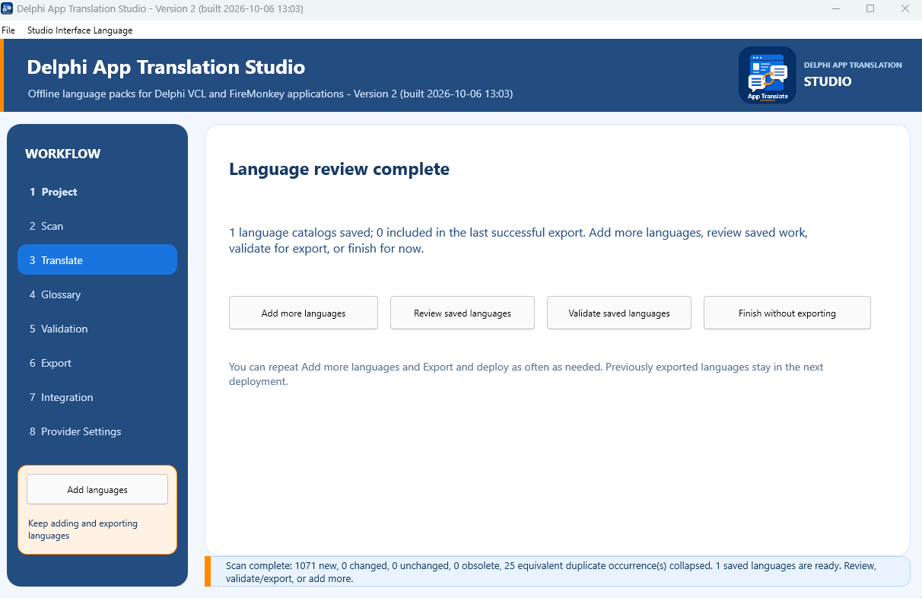
From Language review complete you can add another target, revisit saved work, validate, or finish with drafts saved.

Test the application in use
Install the appropriate DAT design package in RAD Studio and connect the manager and selector on the primary form as described in the Engineering Guide. Build each platform and configuration you distribute. Confirm that a clean build finds the project-local dependency through the developer-set Search path. Run the intended executable with its adjacent Localization\Languages folder.
Switch to each target language and back to source. Check forms, menus, dialogs, dynamic messages, long text, clipping, accelerators, and placeholders. Close and reopen the application to check that language choice persists. For right-to-left languages, inspect the running form and text direction. A visual proposal in Localization Review is a clue, not proof that every control fits.

Test recovery and handoff
From the start screen choose Recover from Safety Backup, select a Studio ZIP, inspect its preview, and restore into a new empty test folder. Confirm the restored project opens without overwriting the working project. Do not replace production files with a test restore. For handoff, record the project, tested builds, tested languages, deployment folders, unresolved warnings, and where the Safety Backup is stored.

